1. **Place HTML elements in Java script codes**

You can place Html elements within **document.write();** and **inner HTML** only java script codes (Html elements inside **alert();** or **console.log** don’t effective).

**Ex:**

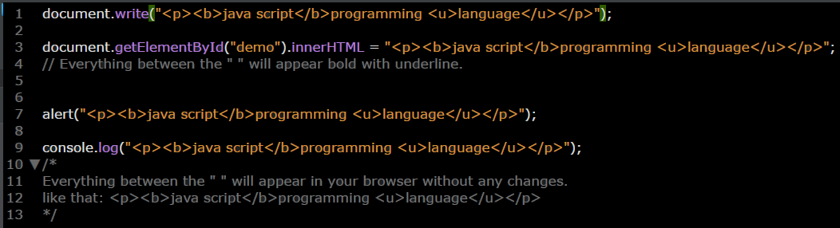

1. **Place HTML attributes in Java script codes**

You can place Html attributes within **document.write();** and **inner HTML** only java script codes (Html elements inside **alert();** or **console.log** don’t effective).

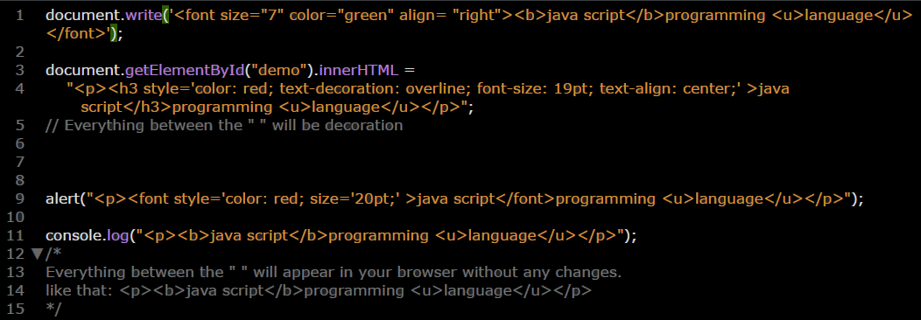

1. **Making table with js, Html, and Css**

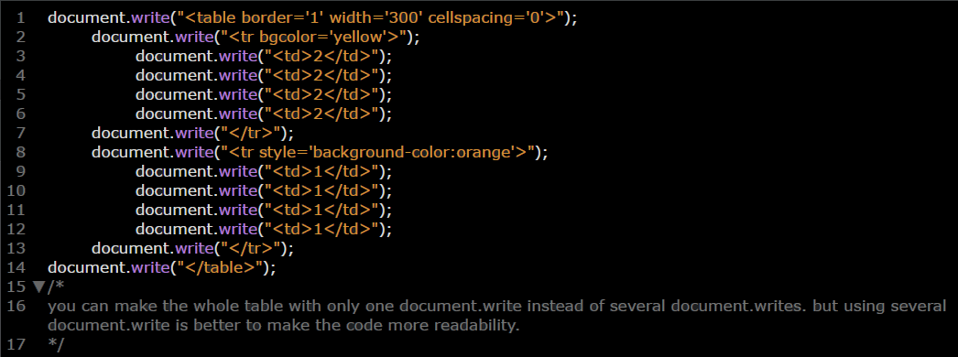

Well now we can really start with java script. Look at this picture to know the composition of java script.

